

Sinhgad Technical Education Society’s

# SINHGAD ACADEMY OF ENGINEERING

Department of Computer Engineering

### **Name :- Sham Anil Mane**

### **Class :- TE (B)**

**Roll No. :- COTB13**

# Assignment III

Title: Generate Dashboard and Reports **Food Order Management System**

**Requirements:** Project Management tools

1. Edrawmax Project Management Software

**Theory:**

Generating the required artifacts and proper documentation is the key to project success. Version control, changes in requirements, rescheduling of tasks, changing priorities of tasks etc. need to be documented. Dashboard facility in Edraw Max provides a wide range of templates to generate and monitor the reports.

Go to File Menu – Business – Project Management – Status Table. Sample screen:

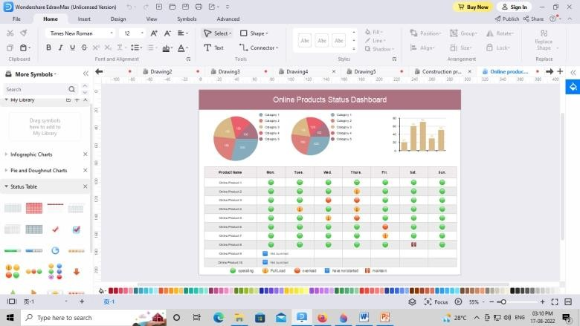

# Dashboard:-

## Project Overview:

The proposed project is about Food Order Management System. The project contains an overview of the Food ordering and the management of the various customer’s database are kept in the management system. The Dashboard basically shows the graphical information of the resources used in the project.

## Cost Overview:

Dashboard shows the cost overview of the project Budget of the project.

## Upcoming Tasks:

Dashboard of the proposed project is also shows upcoming tasks which are involved to complete the task.

## Conclusion:

Thus, we have successfully learnt and created the Dashboard of ‘Food Order Management System’.